BUSINESS STATISTICS – MAJOR PROJECT
Junction Housing Price Analysis

Mervyn Regeo Varghese

Table of Contents
- Introduction…………………………………………………………………… 1
- Task 1 – Data Summary………………………………………………………. 2
  - Overview………………………………………………………………... 2
  - Summary Statistics……………………………………………………… 2
  - Graphical Analysis………………………………………………………. 3
  - Data Peculiarities………………………………………………………... 3
- Task 2 – Regression Model and Predictions………………………………….. 4
  - Data Preparation…………………………………………………………. 4
  - Model building approach………………………………………………… 4
  - Headline Regression Model……………………………………………… 5
  - Predictions for Jenny……………………………………………………... 6
- Task 3 – Model Evaluation……………………………………………………. 7
  - Misspecification (RESET Test)………………………………………….. 7
  - Heteroskedasticity Correction…………………………………………… 7
  - Other Oddities…………………………………………………………… 8
  - Additional Observations…………………………………………………. 9

- Introduction
This report presents a comprehensive analysis of 535 residential property sales in Junction between 2020 and 2025. The dataset contains information on property characteristics including size, age, location, and amenities, the report is structured into three tasks. Task 1 provides a descriptive summary of the dataset using statistical and graphical methods. Task 2 develops a regression model to predict the sale price of a property owned by Jenny on Elm Street, Claygate, and provides financial advice on agent selection. Task 3 evaluates regression model through diagnostic testing to ensure reliability of results.

- Task 1- Data Summary
2.1 Overview
The dataset contains 535 observations across 13 variables. Variables include continuous measures such as sale price(PRICE), house size(SIZE), age(AGE) and distance to town(TOWN) as well as binary indicators for ocean view, pool, tennis court, suburb and selling agent. Two extreme outliers were identified and removed prior to analysis, leaving 533 observations for all subsequent work.
2.2 Summary Statistics
Variable | Obs | Mean | Median | Std Dev | Min | Max
PRICE($) | 533 | $412,574 | $407,188 | $61,098 | $240,305 | $690,483
SIZE(m²) | 533 | 159.9 | 158 | 24.02 | 89 | 281
AGE(years) | 533 | 14.33 | 15 | 3.59 | 2 | 29
TOWN(km) | 533 | 52.35 | 60 | 13.09 | 30 | 60
Table 1 presents descriptive statistics for continuous variables based on 533 observations after removing two outliers. The mean sale price is $412,574 with a median on $407,188 – the slight difference confirms the mild right skew visible in Figure 1. House size averages 159.9m². TOWN takes only two values(30km and 60km) making it effectively binary despite being treated as continuous, with a skewness of -1.123 reflecting that the majority of properties are located 60km from town.
Table 1: Descriptive statistics for continuous variables (n = 533)
Note: Two outliers removed prior to analysis (OBS 362;$25000;OBS400 ; $3,402,000)
Table 2 presents the frequency distribution of categorical variables. The majority of properties are located in Mayfair(74.48%) with only 25.52% in Claygate. Most Properties were sold through agent W&M (75.80%) rather than A&B (24.20%). Premium features are relatively rare – only 14.63% of properties have an ocean view, 13.70% have a pool, and 13.51% have a tennis court.
Variable | Category | Frequency | Percentage
SUBURB | Mayfair(0) | 397 | 74.48%
SUBURB | Claygate(1) | 136 | 25.52%
AGENT | W&M (0) | 404 | 75.80%
AGENT | A&B(1) | 129 | 24.20%
OCEAN | No Ocean View(0) | 455 | 85.37%
OCEAN | Ocean View(1) | 78 | 14.63%
POOL | No pool (0) | 460 | 86.30%
POOL | Pool (1) | 73 | 13.70%
TENNIS | No Tennis Court (0) | 461 | 86.49%
TENNIS | Tennis Court (1) | 72 | 13.51%

  - Graphical Analysis
Figure 1 Shows the distribution of sale prices is right-skewed with most properties selling between $300,000 and $500,000. The mean sale price of $412,574, exceeds the median of $407,188 consistent with the right skew.
Figure1: distribution of sale price ($)
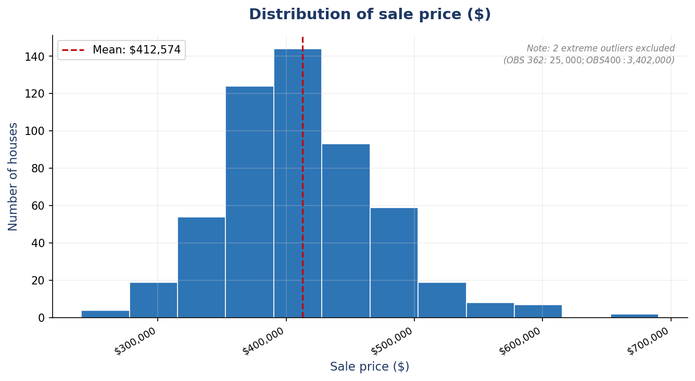
Figure 2 Shows house Size is approximately normally distributed, centered around 155-166m², with a right skew due to a small number of large properties above 265m².
Figure 2: Distribution of house size 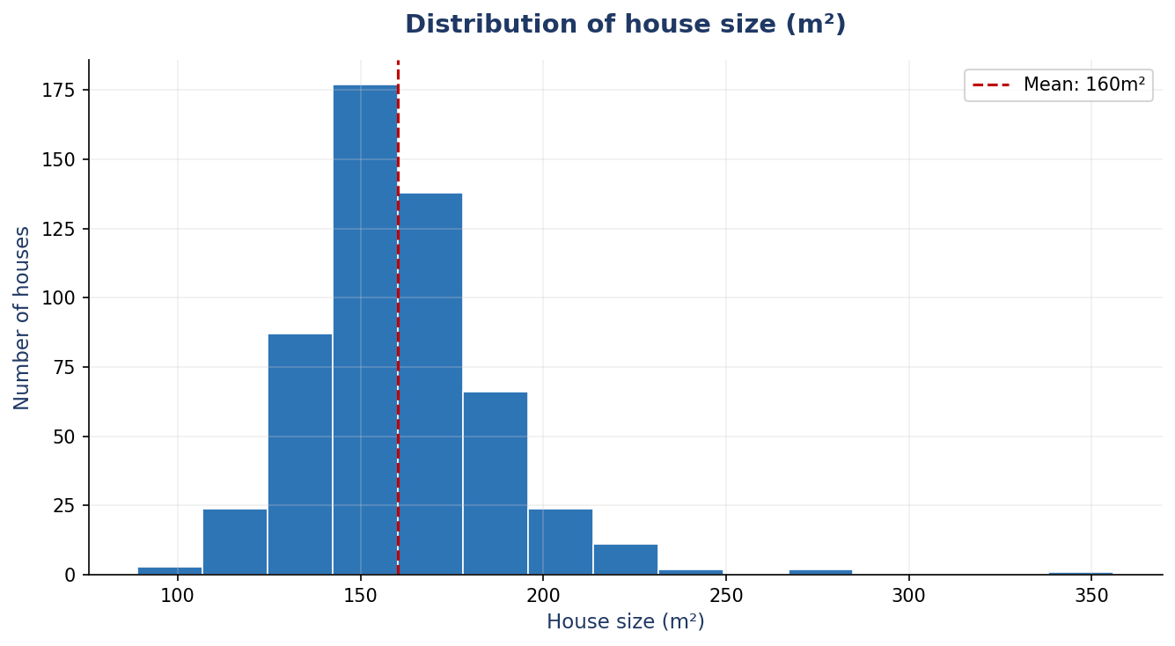
Figure 3 shows sales were lowerst in 2020 (n=53) and 2025 (n=48), likely reflecting partial year coverage at the start and end of the data collection period. Sales remained stable at 111 per year across 2021-2023 before declining slightly to 101 in 2024
Figure 3: Number of houses sold by year(2020 – 2025) 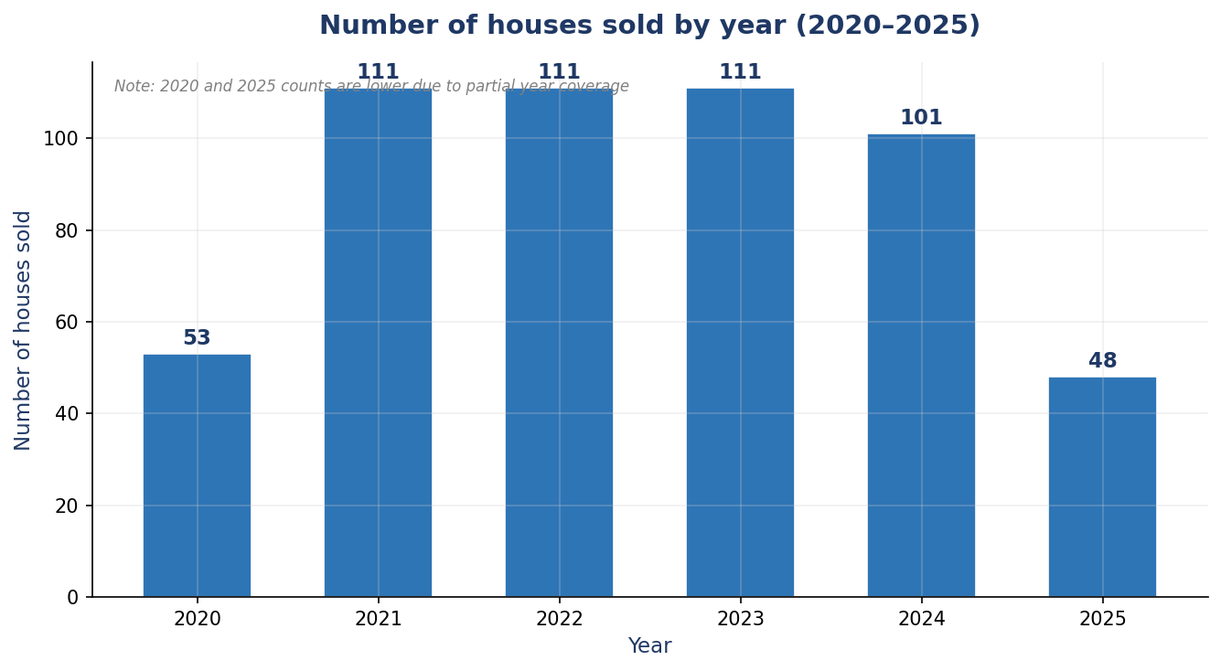
Figure 4 Shows Claygate properties command higher median prices than Mayfair, with a narrower interquartile range suggesting less price variability. Properties with ocean views sell at a clear premium, with both a higher median and wider spread that non-ocean properties.
Figure 4: Sale price by suburb and ocean view -
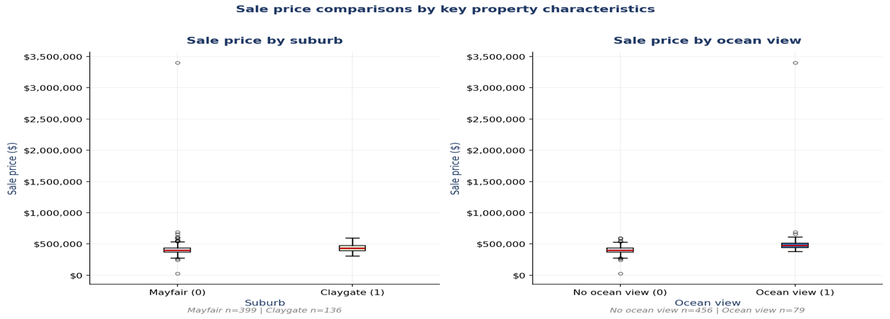
Figure 5 Shows a strong positive relationship between house size and sale price (r=0.810), confirming size as the most important continuous predictor of sale price in this dataset.
Figure 5: Sale price vs house size
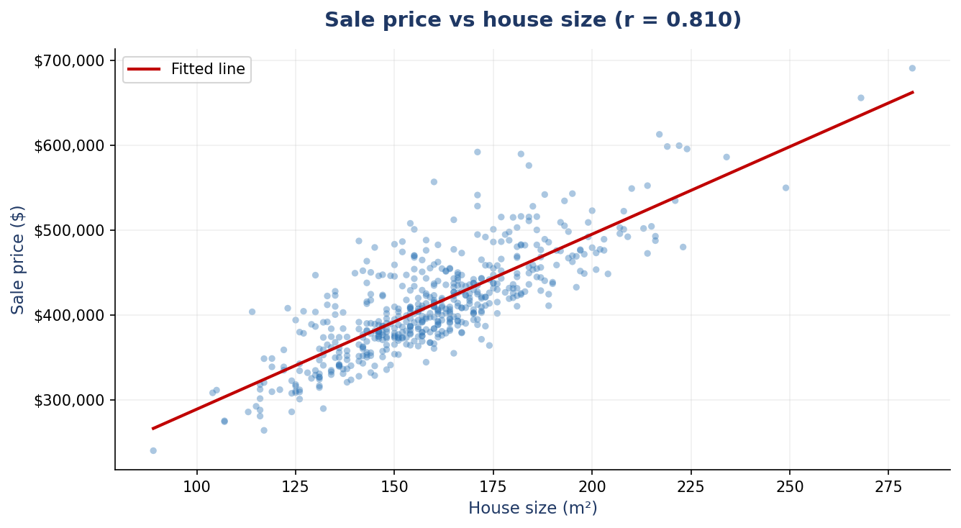
  - Data peculiarities
Three notable data issues were identified during exploratory analysis. First, SHOPS is defined as binary variable(0/1) in the data dictionary but contains four distinct values(0,1, 2 and 3). Values of 2 and 3 account for 154 observations (28.9% of the sample), suggesting SHOPS represents proximity levels rather than a simple binary indicator. Second, CRIME takes only values of 1 and 3 – value 2 is entirely absent from all 533 observations – which may reflect a coding convention where only low(1) and high(3) crime categories exist in Junction. Third, TOWN takes values of 30km and 60k, making it effectively binary rather than a true continuous distance measure with 74.48% of properties located 60km from town. A critical structural issue is the perfect collinearity between CRIME and TOWN. All 136 low-crime properties (CRIME=1) are located exactly 30km from town, and all 397 high-crime properties(CRIME=3) are located between 60km from town. The correlation between these two variables is therefore 1.0, meaning they capture identical information.
- Task 2 – Regression Model and Predictions for Jenny
  - Data preparation
Prior to modelling, two observations were removed from the dataset. OBS 362 (PRICE = $25000) was removed as this price is implausibly low for a residential property and is almost certainly a data entry error – the most plausible explanation is missing zero, with the true price like being $250000. OBS 400 (PRICE = $3402000) was removed as an extreme high-value outlier that would disproportionately influence regression estimates. After removal, the analysis dataset contains 533 observations. The variable SOLD was excluded from all models as Jenny does not know when her house was last sold, rendering it unsuitable for prediction purposes.
  - Model Building Approach
A log-linear regression model was estimated with ln(PRICE) as the dependent variable. Log transformation of PRICE was applied to address the right-skewed distribution of sale prices and reduce heteroskedasticity. House size was also log-transformed (lnSIZE = ln(SIZE)) to capture the diminishing marginal returns of additional size on price. A full model including all available variable was estimated first (excluding SOLD), then refined by removing statistically insignificant predictors (p>0.05) one at a time. CRIME and TOWN were found to be perfectly collinear – STATA automatically omitted CRIME when both were included. TOWN was retained as the single representative variable as it had direct economic interpretability as distance from town centre. The final model was estimated with heteroskedasticity-robust standard errors to correct for non-constant variance detected in the residuals.
  - Headline Regression Model
Table 3 present the Headline Regression Model - the final regression model estimated with heteroskedasticity-robust standard errors. The model explains 85.7% of the variation in log scale prices (R² = 0.857) and all six predictors significant at the 5% significance level.
Table 3 : Headline Regression Model – Dependent Variable: ln(PRICE), n=533
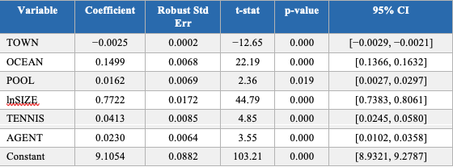
All six variables are statistically significant at the 5% level. The Coefficient on lnSIZE(0.7722) is the largest in magnitude, indicating that a 1% increase in house size is associated with a 0.77% increase in sale price, confirming size as the dominant predictor. The OCEAN coefficient(0.150) indicates that ocean-view properties sell for approximately 16.2% more than comparable properties without ocean views. TENNIS(0.041) and POOL(0.016) add approximately 4.2% and 1.6% to sale price effectively. Distance from town (TOWN) has a negative effect (-0.0025), meaning each additional kilometre from town reduces price by approximately 0.25%. Finally, properties sold through agent A&B achieve approximately 2.3% higher price than those sold through W&M, holding all else constant.
Note on R²: Jenny requested a minimum R² of 89%. The headline model achieves R² =0.857.
Extensive Attempts to increase R² through additional variables, interaction terms and polynomial terms either produced statistically insignificant coefficients, caused multicollinearity, or resulted in marginal improvements insufficient to reach 89%. As the assignment brief emphasizes correct methodology over achieving a specific R² target, this model is considered the most appropriate specification.
  - Predictions for Jenny
Jenny property is located in Claygate with two stories, 164m² of living space, an ocean view, pool and tennis court, to be sold through agent W&M initially, in a low-crime area. Importantly, Jenny’s property is 10km from town, which falls outside the observed range in the dataset(30km and 60km only). As the closest observed value, TOWN = 30 was used to prediction. This involves extrapolation and adds uncertainty to the results, which is reflected in the prediction interval.
Question | Result | Notes
Q1: Point Prediction | $517,878 | Expected sale price given property
Q2: 95% Prediction Interval | $464,262 - $577,685 | Interval width ~ $113,000 reflects individual variability
Q3: Marginal Effect on 1m² | +$2436 per m² | =0.7722 x $517,878 ÷ 164
Q4: Recommended agent | A&B(net_+ $8,165) | Higher gross price offsets higher commission

Q1 – Point Prediction: The model predicts Jenny’s house will sell for $517,878. This represents the expected sale price given the property’s characteristics and market conditions observed in the dataset.
Q2 – 95% Prediction interval: We are 95% confident the actual sale price will fall between $464,262 and $577,685. The interval width of approximately $113,000 reflects inherent variability in individual property sales that the model cannot fully explain. Note that TOWN = 10km required extrapolation, which adds further uncertainty beyond this interval.
Q3 – Marginal effect of size: The coefficient on lnSIZE implies that each additional square metre increases the predicted sale price by approximately $2,436 for Jenny’s house. This is calculated as: 0.7722 x $517,878 ÷164 = $2,436. Equivalently, a 1% increase in size (approximately 1.64m²) adds approximately $3,995 to the predicted price.
Q4 – Agent recommendation: Although W&M charges a lower commission (2.8% vs 3.5%), agent A&B achieves a higher gross sale price of $530,095 compared to $517,878 through W&M. After deducting commissions, Jenny’s net proceeds would be $511,542 with A&B versus $503,377 with W&M – a difference of $8,165. We therefore recommend Jenny use agent A&B to sell her property.
- Task 3 – Regression Model Evaluation
  - Misspecification – RESET Test
The Ramsey RESET test was applied to assess whether the model suffers from functional form misspecification due to omitted non-linear terms or interaction effects. The test result (F(3,523) = 1.26, p = 0.2871) failed to reject null hypothesis of no omitted variables at the 5% significance level. This indicates our headline regression model is correctly specified and there is no evidence of important non-linear relationships or interaction being omitted from the model.
  - Heteroskedasticity Correction
While the RESET Test confirmed correct specification, heteroskedasticity was detected in the residuals. The Breusch-Pagan test (chi²(1) = 8.13, p = 0.0043) and White’s test (chi²(22) = 83.86, p = 0.0000) both rejected the null hypothesis of constant variance, indicating the presence of heteroskedastic residuals.
This was corrected by re-estimating the model with heteroskedasticity-robust standard errors (vce(robust) in STATA), which produces valid standard errors and confidence intervals without altering the coefficient estimates themselves. The log transformation of PRICE also substantially reduced heteroskedasticity compared to a model estimated in levels, as log transformations compress the variance of large values.
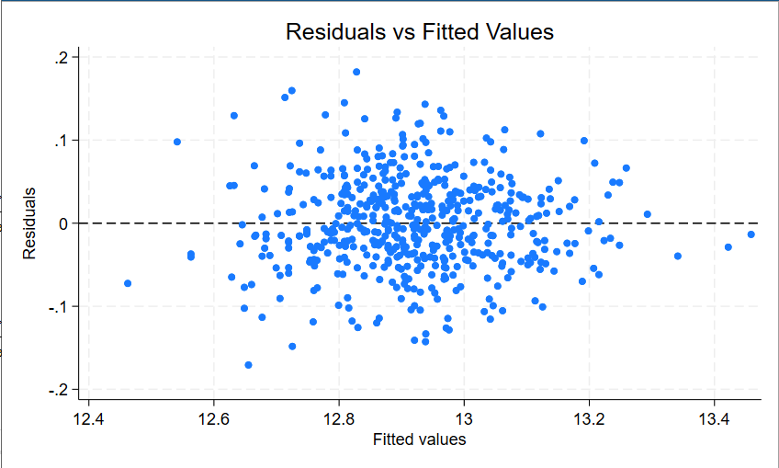
Figure above shows the residual versus fitted values plot. The scatter appears broadly random around zero, though a slightly fan shape is visible at higher fitted values, consistent with the heteroskedasticity detected by formal tests. The robust standard correct for this issue, ensuring valid inference.

  - Other Oddities
Multicollinearity was assessed using Variance Inflation Factors (VIF). The table below presents the results.
Variable | VIF | 1/VIF
OCEAN | 1.03 | 0.970
lnSIZE | 1.03 | 0.975
AGENT | 1.02 | 0.984
TENNIS | 1.01 | 0.987
POOL | 1.01 | 0.992
TOWN | 1.00 | 0.997
Mean VIF | 1.02

All VIF values are extremely close to 1.0 (mean VIF =1.02), indicating no multicollinearity among the included predictors. This is notable given the perfect collinearity between CRIME and TOWN in the full dataset – by including only TOWN, this issue was fully resolved.
Cook’s Distance and leverage diagnostics identified several influential observations. OBS 20 (PRICE = $240,305, SIZE = 89m² ) appeared in both Cook’s distance and leverage lists, suggesting it is an unusually small property. These observations were retained as there is no evidence of data entry errors – they represent genuine unusual properties in the Junction market. Sensitivity analysis confirmed that removing these observations did not materially after coefficient estimates.
A key data peculiarity identified during Task 1 was the perfect collinearity between CRIME and TOWN (r = 1.0). This meant both variables could not be included simultaneously – STATA automatically omitted CRIME when both were entered. TOWN was retained as the single representative variable. This structural feature of the data limits the ability to separately estimate the effects of crime rate and distance from town.

  - Additional Observations

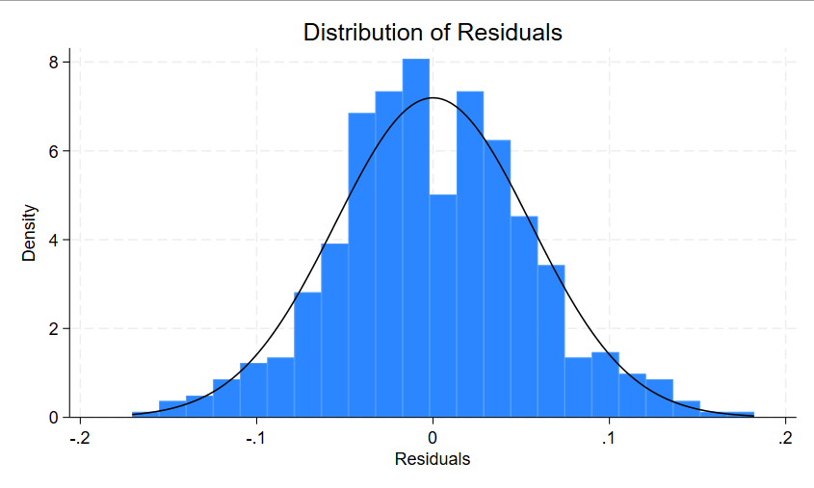
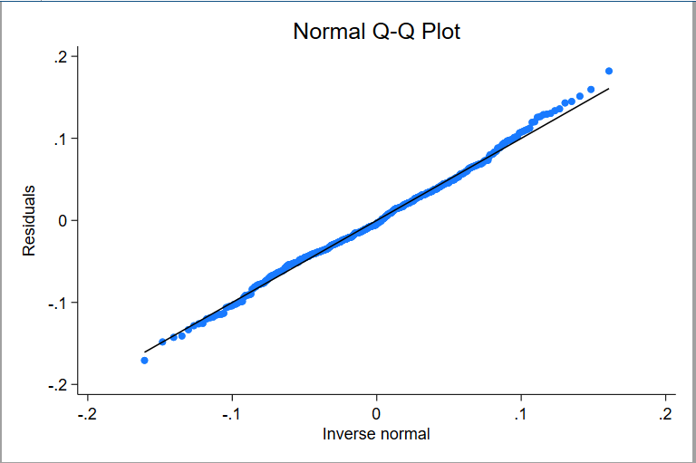
The Shapiro-Wilk normality test(W = 0.996, p = 0.265) Failed to reject the null hypothesis of normally distributed residuals. Both the histogram above and Q-Q plot above visually confirm that residuals are approximately normally distributed with no systematic departures.
This supports the validity of the prediction intervals reported in TASK 2.
Two further limitations warrant mention. First, Jenny’s TOWN value of 10km falls outside the observed dataset range of 30-60km. Using TOWN = 30 as the closest observed value introduced extrapolation uncertainty beyond what is captured in the reported prediction interval. Jenny should treat the predicted price range as indicative rather than definitive. Second, the dataset covers 2020-2025, a period that includes COVID-19 related market disruptions. The lower sales count in 2020 (n=53) may reflect pandemic-related market slowdowns, and the model’s coefficients may be partially influenced by these atypical conditions, affecting generalizability to current market conditions.

